
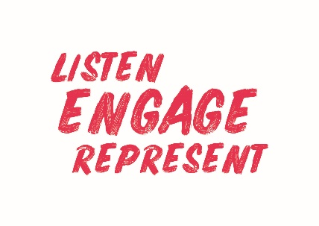
Welsh Athletics Endurance Officials Meeting Minutes
Held on the 11 October 2021
Meeting held remotely via video link

Apologies: Jamie Clode, Rhiannon Linington-Payne, Jacqueline Brace
Papers circulated in advance:
Actions from meeting
Item Number | ACTIONS | Person responsible
4 | Update Trinity about the retirement of Terry Goodwood | Sue
5 | Update committee about the possible webinar for Trail/Mountain Running Officials following meeting with Arwel on November. | Zoe
4 | Explore possibility of a risk assessment course to be held before Christmas | Zoe
8 | Members asked for ideas for officials conference March 2022 | All

Present:,
- Zoe Holloway, Paul Brooks, Nigel Jones, Christine Vorres, Sue Hooper – Apologies: Jacqueline Brace, Jamie Clode

- Previous Minutes
The August minutes were declared as a true record.

- Declaration of Interest
None declared

- Discussion items
Volunteer role descriptions for endurance regional secretaries have been completed and circulated. Zoe stated a Volunteers notice board will be created for the Welsh Athletics website.
Risk awareness course was delivered on 25th September. Attendance could be improved. Possible ways of improving attendance were discussed for online and face to face courses. Maybe charging would improve commitment to attend. No decision taken. Currently there are 7 endurance officials across the regions who need to do the course.
5. Updates / Reports / Information for circulation
Sue updated the members on the situation regarding Officials for the Commonwealth Games next year. The process of selection is underway and an update will be available in December. Costs are covered for Officials but not for Volunteers.
Zoe is communicating with Arwel about a webinar for Trail/Mountain Running officials but he is extremely busy at the moment. They have a meeting in November, and there is an idea to host it during the Officials Conference. The date for the Conference has been set for 6th March 2022.
No update on Race Directors courses at the moment.
6. Correspondence - None
7 . Information Jacqueline provided the members with a list of events to date that have applied for licences for information only.
8. Regional Development Plan Update
No update
9. AOB
Zoe confirmed the date for the Officials Conference to be 6th March 2022. And asked for ideas for items to include to be emailed to her.
Officials Kit – Zoe advised there is a slight delay in the kit arriving and it is likely it will now be available in November.
Sue advised that Lesley Stow has been appointed as volunteer coordinator for the Gwent Cross Country league. Many of the officials who normally take up the roles required have agreed to continue.
The meeting ended at 6.20pm.
Next meeting date: 6th December 5.30pm.
Minutes Written by Christine Vorrès 11 October 8.30pm.

